**Design & Technology**

**

**Metal processes**

**Materials required for questions**

* Pencil
* Rubber
* Calculator

**Instructions**

* Use black ink or ball-point pen
* Try answer all questions
* Use the space provided to answer questions
* Calculators can be used if necessary
* For the multiple choice questions, circle your answer

**Advice**

* Marks for each question are in brackets
* Read each question fully
* Try to answer every question
* Don’t spend too much time on one question

**Good luck!**

**Q1.** Which welding method uses a consumable wire electrode and inert gas shielding?

**A** Oxy-acetylene welding

**B** MIG welding

**C** Spot welding

**Q2.** What is a key advantage of TIG welding over MIG welding?

**A** Faster process for thick metals

**B** Lower skill requirement

**C** Greater precision and cleaner welds

**Q3.** Which process is suited for creating cylindrical parts like shafts?

**A** Turning

**B** Deep drawing

**C** Forging

**Q4.** Which process shapes metal by forcing it into a die with a punch?

**A** Spinning

**B** Press forming

**C** Rolling

**Q5.** Explain why die casting is an appropriate manufacturing method for the model toy vehicle shown below **(6 marks)**

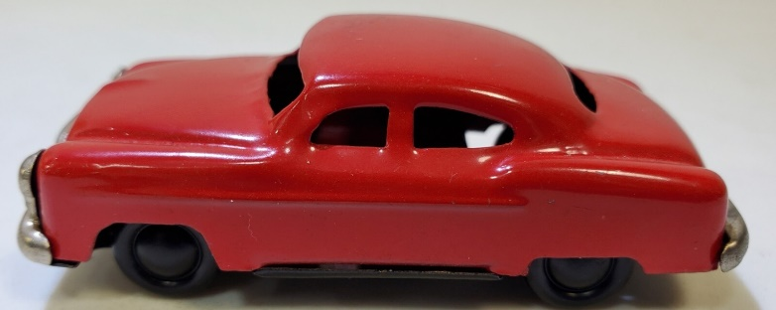

**Q6.** Explain the manufacturing processes that would be used to manufacture the stainless steel ruler shown below **(6 marks)**

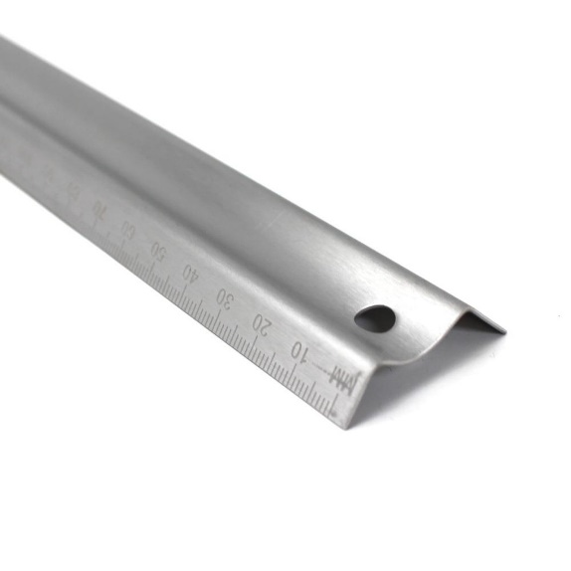

**Q7.** Describe the main stages in the process of soft soldering **(6 marks)**

**Answers**

**Q1**. B

**Q2**. C

**Q3**. C

**Q4**. B

**Q5**.

* The manufacture of the die casting moulds is both complex and costly making it prohibitive for small scale manufacture. The model vehicle is sold worldwide in large volumes, justifying the use of die casting.
* Die casting produces a product with an extremely high-quality surface finish, suitable for representing the body panels on the model vehicle.
* The high-quality surface finish then allows for additional surface finishes to be applied without extensive surface preparation.
* The die cast moulds are reusable meaning that each model vehicle will be accurately produced to the same design.
* Die casting produces a mould with consistent dimensional accuracy which allows for components such as the windows and wheels to be accurately attached.
* Pressure die casting is an appropriate process to produce intricate designs such as the model vehicle logo and patterns to represent the doors and windows.
* Thin sections or thin wall thicknesses can be achieved which allow features such as the window pillars to be successfully produced.

**Q6.**

* The debossed detail such as the brand name, the mm incremental indicators and the numbers on the ruler would have been achieved by stamping the stainless steel with an appropriate die under hydraulic pressure. Several rulers may be stamped simultaneously.
* Following the debossing, the rectangular blank needed for the ruler would have been created from a larger sheet by punching the rectangular profile using a series of dies.
* Detail such as the hanging hole would have been incorporated into the same punching die to improve efficiency.
* The debossed, punched blank would now be press formed into the desired profile for the ruler.
* The male and female die used would be produced from hardened steel in order to resist the wear of constant use.
* The stainless steel material would be compressed between a male and female die under significant hydraulic pressure in order to produce the ‘m’ profile seen on the ruler.
* The press formed profile would be removed from the hydraulic press, inspected for quality before being packaged.

**Q7.**

* The components should be clean and free from grease or impurities.
* Flux may be used to help the solder flow and prevent oxidisation when heating. The flux can be added separately or may be present in the core of the solder itself.
* The components should be held in place while being heated to approximately 200C
* Heating can be undertaken with a soldering iron, small gas blow torch or hot air gun depending on the application.
* The solder should be added to the joint.
* The heat source should be removed and the component or join allowed to cool in order for the solder to return to a solid state.
* Any excess flux should be removed to prevent corrosion.
* An electrical circuit may be tested after soldering as part of effective quality control.
* A solder bath may be used to solder several components to a complete circuit board at one time.